Convolutional Neural Networks

Table of Contents

Edge Detection 3

Convolution 5

Advantages 7

Filters 7

Padding 9

Strided Convolutions 11

Convolution Over Volumes 12

Convolutions on RGB Images 13

Multiple Filters 14

Adding Bias 15

Activation Function 16

Notation 16

Example 17

Pooling Layers 22

Max Pooling 22

Filter Sizes and Stride Values 23

Channels 24

Other Pooling Methods 25

Forward Propagation 28

Softmax Layer 29

Well-Known Architectures 30

LeNet-5 30

AlexNet 31

VGG-16 31

Vanishing and Exploding Gradients 32

Residual Networks 33

1 x 1 Convolutions 34

Inception Networks 34

Inception Modules 34

Computation Costs 35

One of the fundamental issues we mentioned when we first started studying neural networks is the huge number of input features. However, we have not actually solved this issue yet. If we have a 1000 x 1000 pixel image in RGB, we will still end up with 3 million input features to feed to our neural network. If the first hidden layer has 1000 neural units, the weight matrix will be of size 1000 x 3 million. If we go to the second layer and propose that it also have 1000 neural units, then the weight matrix will be of size 1000 x 1000. This in itself is a huge problem, regardless of how well a neural network performs compared to normal logistic regression, since the model will be extremely computationally expensive to train.

To help deal with this, we will use a new layer called a **convolution layer**.

## Edge Detection

Given a particular image, it is possible to detect the edges of the different elements in the image. For example, we can consider all the horizontal and the vertical edges.

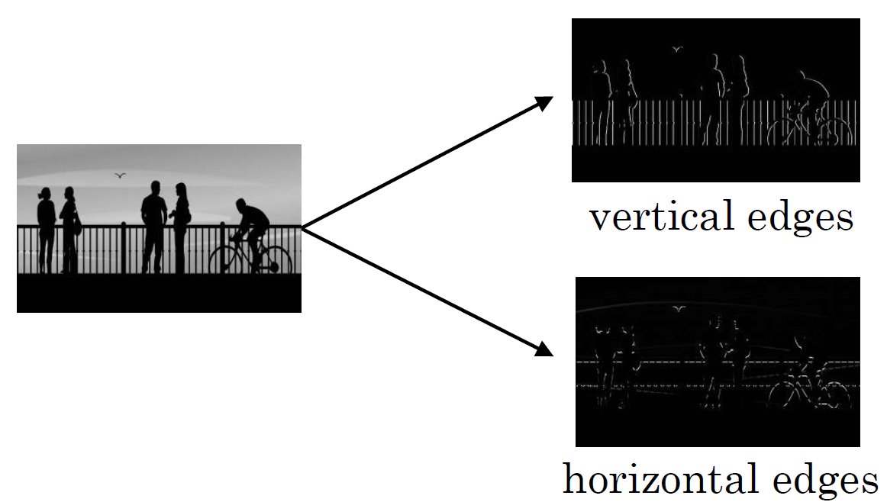

One of the basic tasks in image processing is to detect edges like this, a process called **edge detection**. Edges in every possible direction are detected, not just horizontal and vertical ones. An edge would be detected at a point in the image where the colour changes or the intensity of the colour changes.

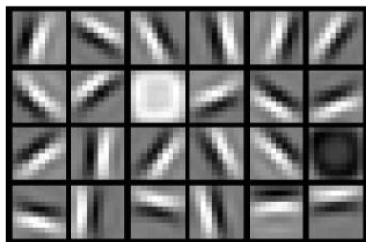

These edges can be combined to create structures, which can then be combined to create entire images.

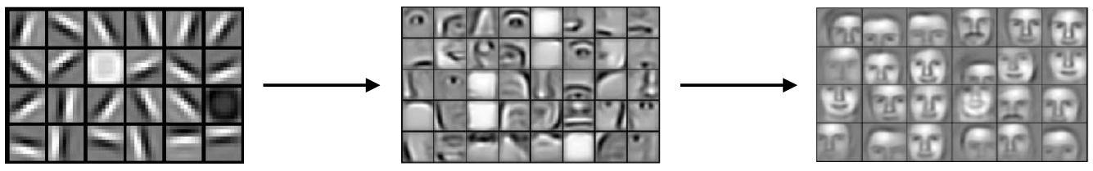

All of this starts with the process of edge detection. This process is handled by an operation called the **convolution operation**, which happens in the convolution layers.

## Convolution

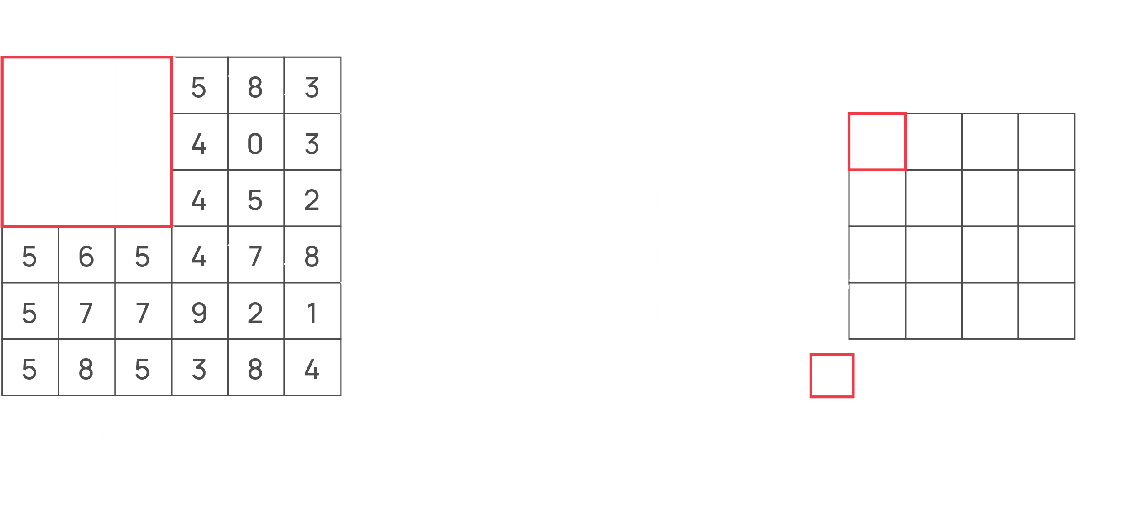

The above operation is a single step of **convolution**. We have a matrix called the **filter** (also called a kernel or a window) and another matrix which provides the **input**. We are taking the top-left most section of the input matrix, which has the same shape as the filter, and summing the product of the elements in each cell to get the first element of the result. This single element is called a **convolution response**.

In the next step, we shift the part of the input matrix we have selected one column to the right.

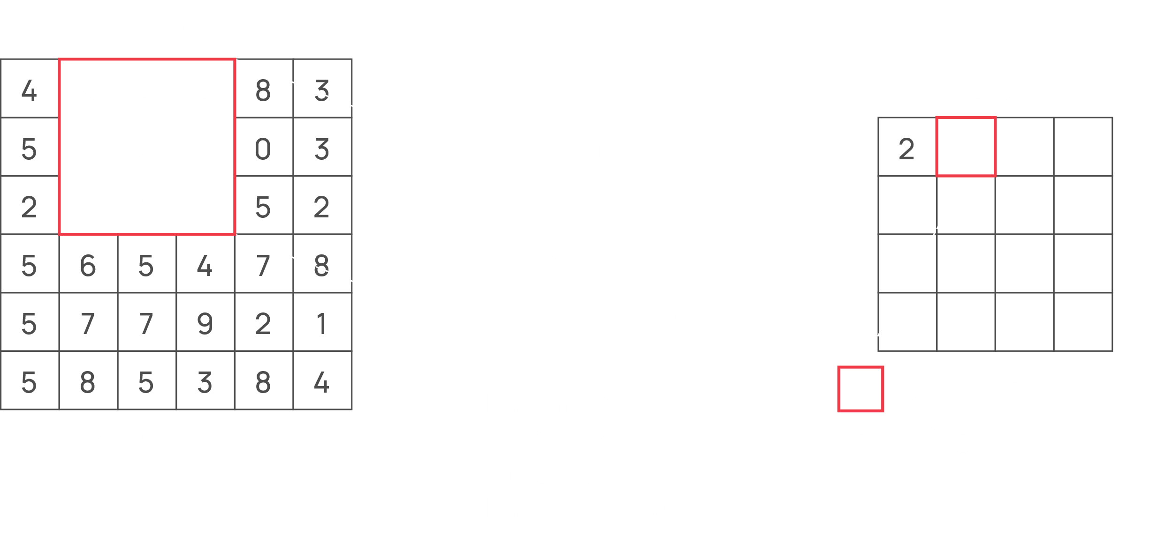

This process continues with the section of the input going from left to right and from top to bottom.

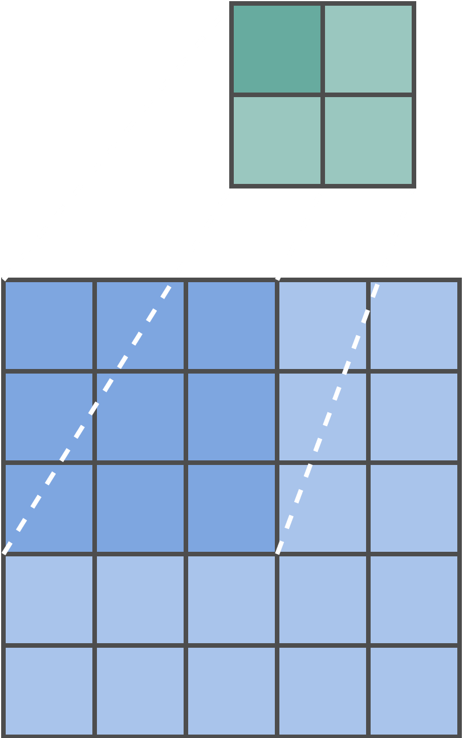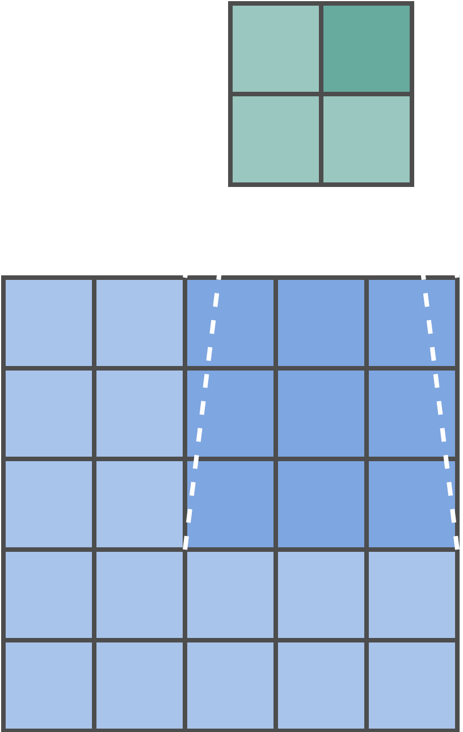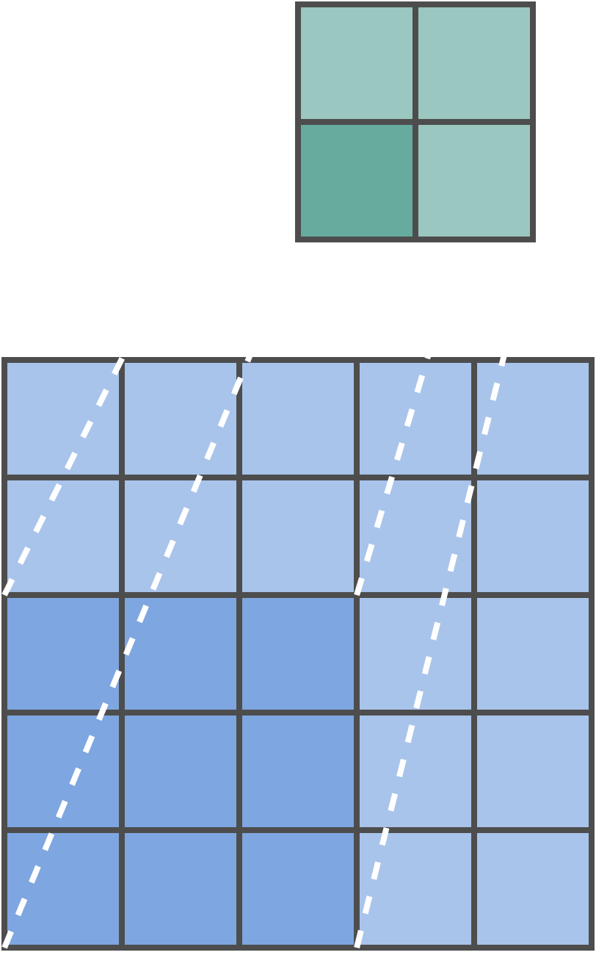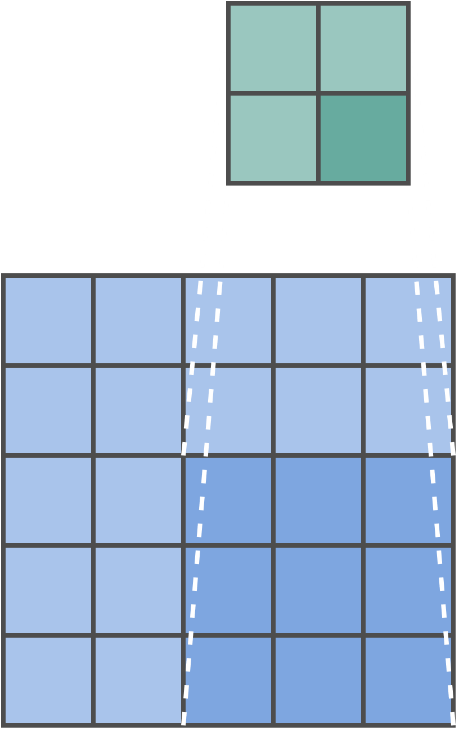

Thus, since the filter is 3 x 3 and the input matrix is 6 x 6, the result matrix is 4 x 4. For an $n×n$ input matrix and an $f×f$ filter, we will get an $\left(n-f+1×n-f+1\right)$ resultant matrix. Since the input matrix is fixed, the **size of the filter** will determine the size of the output.

If it wasn’t already clear, the input matrix is just the input image. We are considering a black and white image for simplicity. The convolution operation then depends on the **filter**.

Technically speaking, the operation above is actually **cross-correlation**. In true convolution, the filter must be flipped both horizontally and vertically before being applied. We will not be doing this though.

### Advantages

Using convolution operations provides us with mainly two benefits:

* **Parameter Sharing** – Every section of the input matrix uses the same filter, so the weights of the filter (the parameters) are being shared. Thus, using just a few numbers, we are able to detect edges.
* **Sparsity of Connections** – Each convolution response depends on a small sub-section of the input. The different responses are not connected to each other.

## Filters

We will now examine exactly how the convolution operation allows us to detect edges. To start with, we will consider vertical edges specifically. The operation below is similar to the previous example, except that the input matrix has been changed.

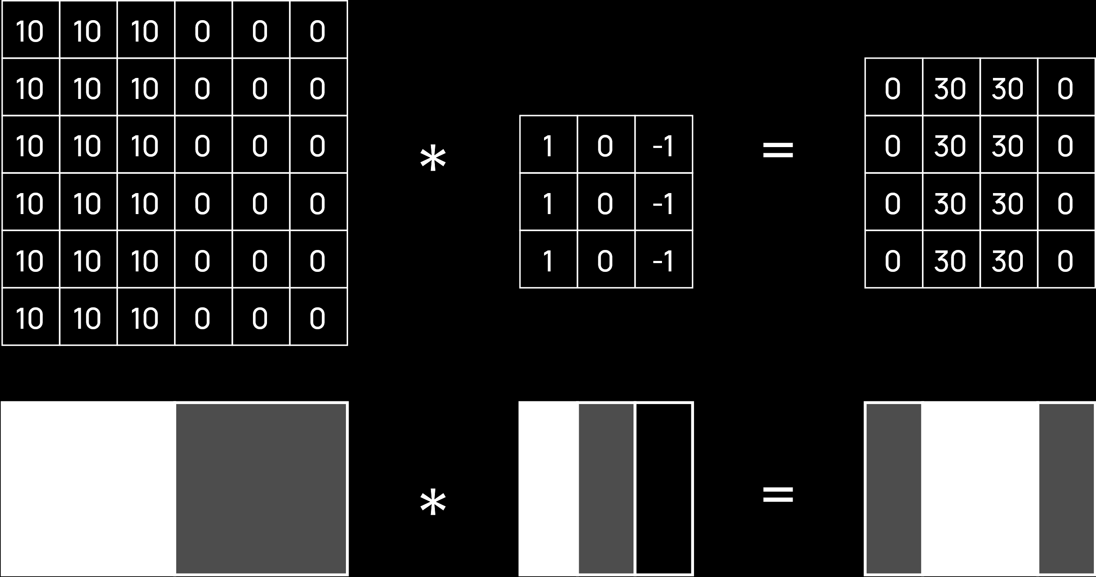

The input matrix is a very simple one with an obvious vertical edge. In the output matrix, we have significantly high values on both sides of where the vertical edge should be (the centre) and 0 responses elsewhere. These high values are how we will go on to determine that this is where the vertical edge is.

The problem is that the output depends on the filter matrix. Here, we have specified some weight values. The $1$ s on the left are looking for a white section, the $1$ s on the right are looking for a dark section while the $0$ s in the middle are ignoring the central section. Thus, a light to dark transition is detected. But how would we even find the weight values in the first place? Thus, it is the goal of the convolutional neural network to determine the weights.

For example, consider we use a different filter.



This filter is supposed to be used for **horizontal edges**, but since the provided input matrix does not have any horizontal edges, the output matrix is $0$ everywhere. When training the model, if the model tried this filter, it would realize from the output that the results are not correct and would try a different filter.

Note that it is not necessary that the exact filter shown above be used to detect vertical edges. The model can come up with any one of **several filters** to detect the same edges.

But we are not just trying to detect vertical or horizontal edges. Edges can be in **any direction**. For each type of edge, such as edges at $30°$, at $45°$, etc., the filter will be different.

## Padding

So far, we have seen that we place a filter on top of an input matrix to get an output matrix. However, due to the size of the filter, we were forced to take an output that was of a different size than the input. This was a problem because the values on the edges of the input matrix had a smaller effect on the overall output.

If we wish to not shrink the height and width when using convolution, we can use **padding**.

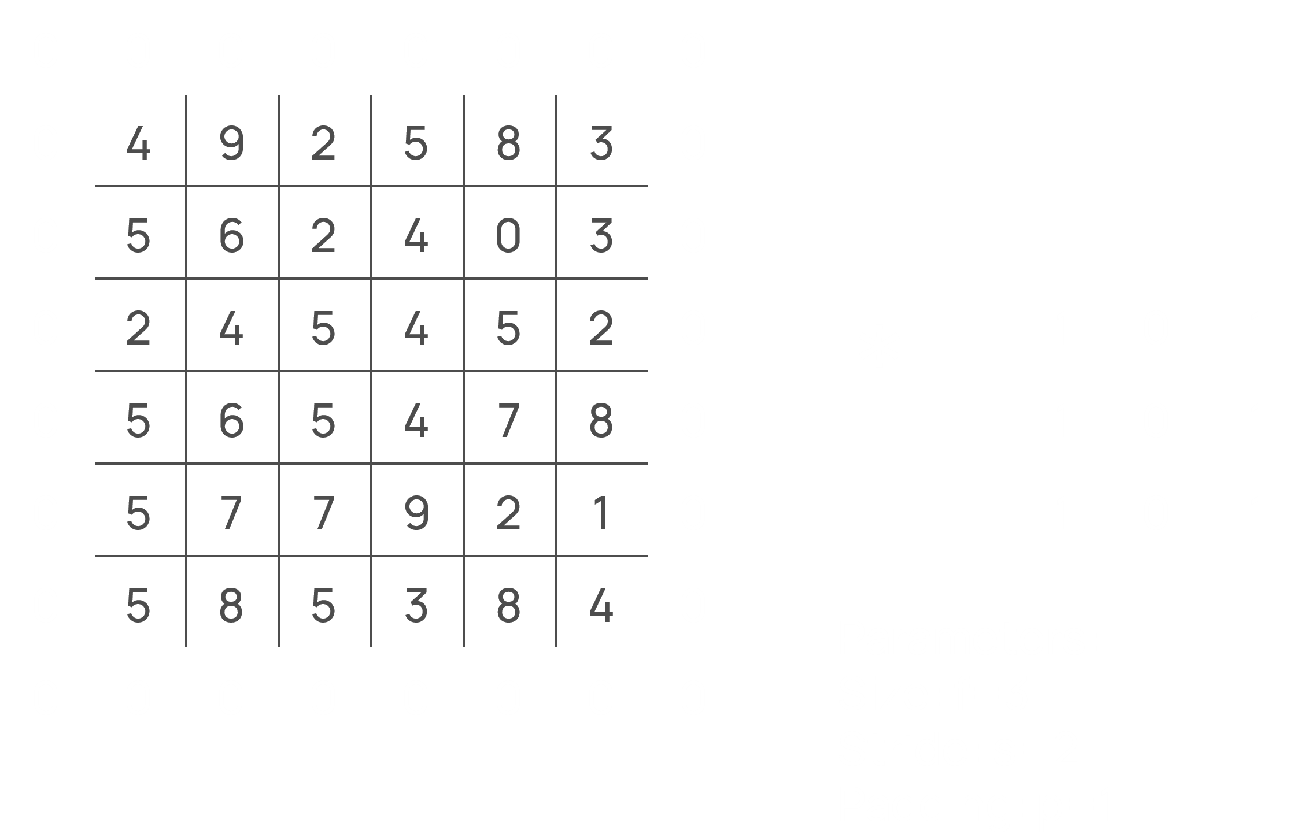

For a filter of size 3 and an input matrix of size 6, we can add a single layer of padding, as shown above, to achieve an output matrix of size 6. The padding is always a layer of 0s wrapped around the input matrix. This allows us to place the centre of the filter on the top-left edge of the actual matrix, thus ensuring that every element of the input matrix contributes equally to the output.

For filters that are larger, the amount of padding will need to be increased. If we had an input matrix of size 6 and a filter of size 5, then we would need two layers of padding around the input matrix to ensure that the output matrix stayed the same size.

Using padding becomes important when we are dealing with **deep networks**, since otherwise, the matrix would shrink more and more as we go further into the network.

The case where we do not have any padding is called **valid padding** (no clue why). In this case, for an input of size $n$ and a filter of size $f$, the output would be of size $\left(n-f+1\right)$. The case where padding is used is called **same padding**. In this case, the padding size is $p=\frac{f-1}{2}$ and the output is of size $\left(n+2p-f+1\right)$.

## Strided Convolutions

For each step of convolution, we shift one pixel to the right. The number of pixels we are shifting is called the **stride**. Thus, we had a stride of $s=1$. We can however, change this. For example, suppose we have a stride value of $s=2$. The centre locations of the possible filter positions then become like this:

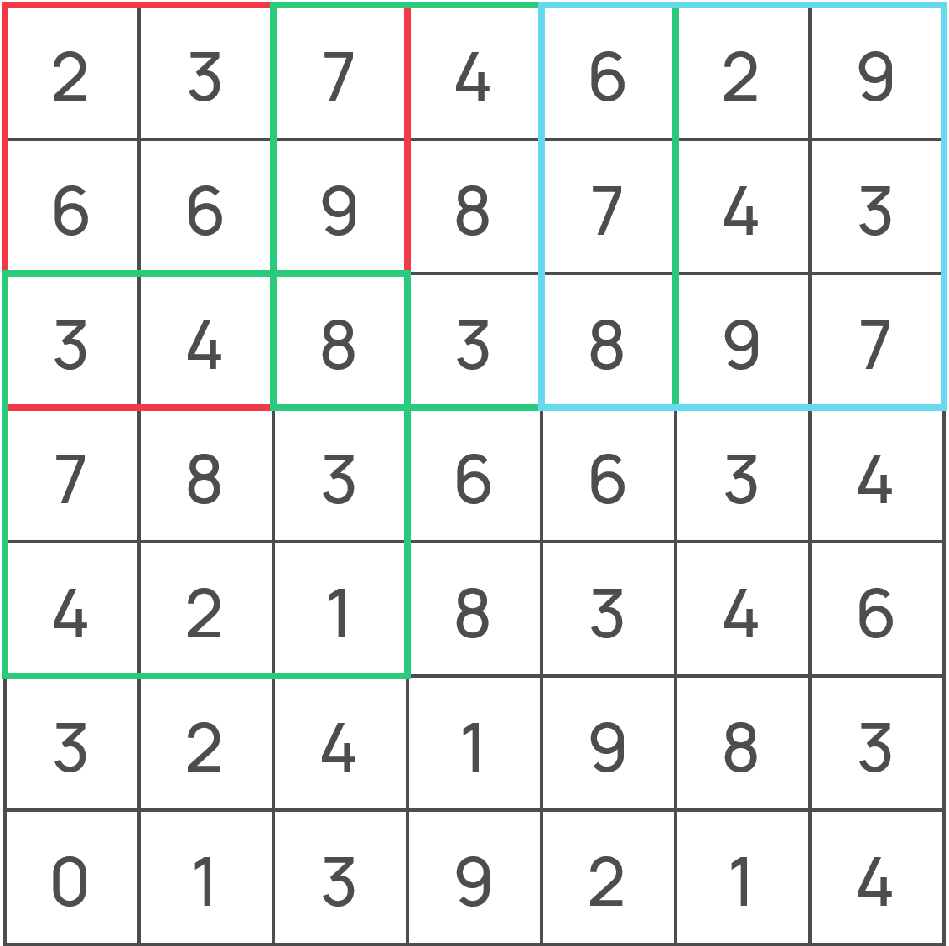

Note that the **vertical stride** also changes and, as always, the entire filter must fit inside the input matrix wherever we place it.

For the above input matrix, which is of size $7$, if we are using a filter of size $3$., we will get an output of size $3$. The formula to calculate this is $\left\lfloor \frac{n+2p-f}{s}+1\right\rfloor$.

Using a higher stride value allows us to reduce the size of the image. If we have a stride value of two, we are essentially skipping every other row and column. Thus, instead of working with an $n×n$ input matrix, we are technically working with a $\frac{n}{2}×\frac{n}{2}$ matrix. This is similar to a technique called **down sampling**, where the rows and columns are removed entirely. It is not exactly down sampling, since the rows and columns we are skipping over still contribute to the convolutions for the rows and columns we keep.

In summary, we have **three hyperparameters** when dealing with convolution operations, the size of the filter, $f$, the number of layers of padding, $p$, and the amount of stride, $s$. For an input matrix of size $n$, we will get an output matrix of size $\left\lfloor \frac{n+2p-f}{s}+1\right\rfloor$.

## Convolution Over Volumes

When the input has **multiple channels**, e.g. an RGB image, the filter needs to have a **matching number of channels**, $n_{c}$. Each of the channels will just be a repetition of the **same filter**, and will be multiplied by one of the input channels. Once this is done, we will take the **element-wise sum** of all $n_{c}$ results to get a **single channel output**.

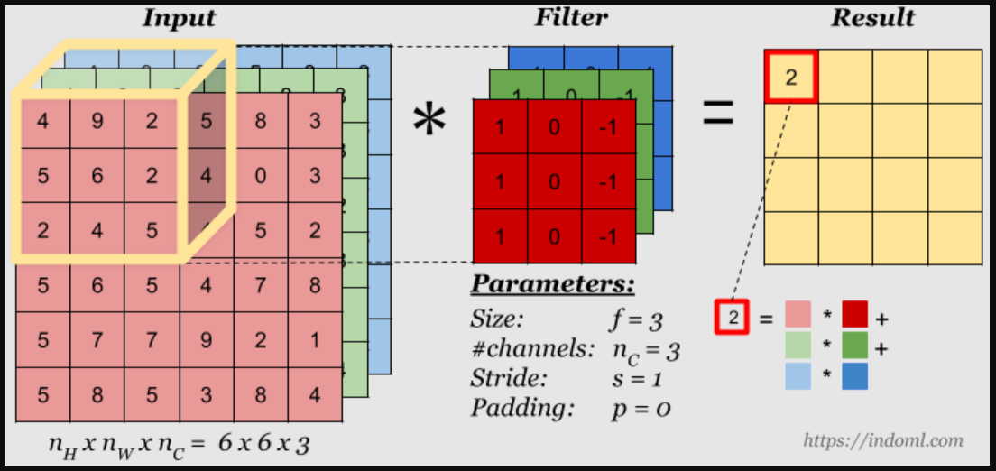

A simple representation of a block with multiple channels is to use a **3D Cube**, as shown below. This representation is frequently used.



## Convolutions on RGB Images

Consider the case above again, with an RGB image as an input and a 3-channel filter in between being used to detect vertical edges. Instead of applying the same filter thrice, suppose we apply the following three filters to the R, G and B channels respectively.

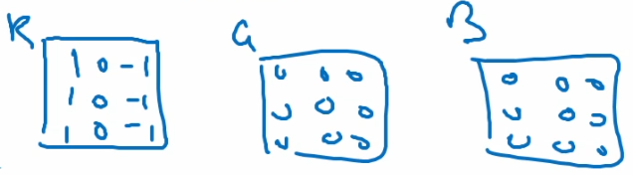

Using these filters will result in us detecting vertical edges in the red channel specifically. This indicates that all three filter channels don’t actually have to be the same. However, if we are trying to detect edges in general, we need to detect them in all three of the R, G and B channels, which is why we kept them the same.

## Multiple Filters

We can also apply **multiple filters** to the same input, with each filter detecting **edges in different directions**. Each of the filters will give us a **separate output**.

Suppose we have one filter detecting vertical edges and another one detecting horizontal edges. Thus, we will have two outputs.

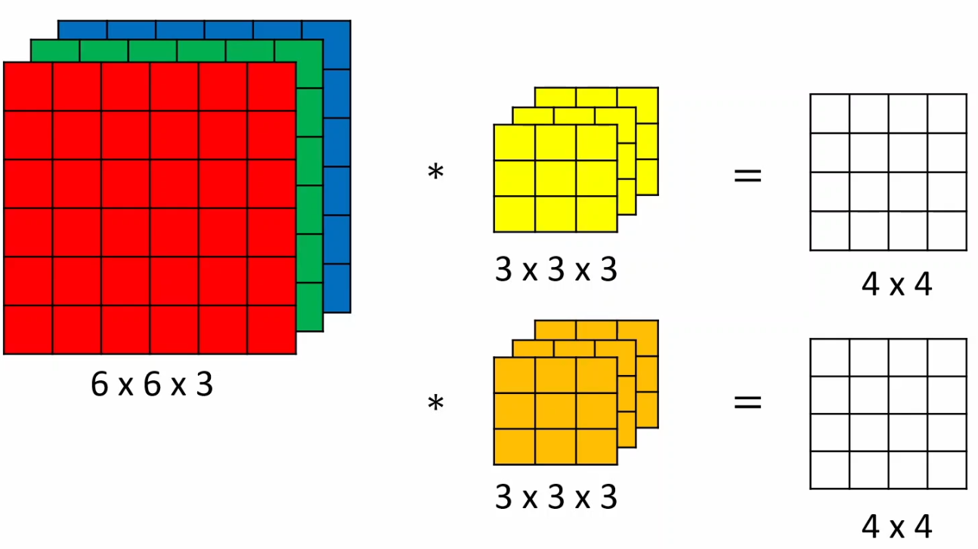

We can then **stack the outputs** to form a $4×4×2$ output.

Each filter is like a neuron of a neural network, so having multiple filters is like creating a **layer**.

Note that in this case, all the filters have to be of the **same size**, so that the individual outputs are of the same size. Otherwise, we will be unable to stack them.

## Adding Bias

In a neural network, we can have something called a **convolution layer**. In a normal neural network layer the equations that we compute are $Z^{\left[l\right]}=W^{\left[l\right]}A^{\left[l-1\right]}+b^{\left[l\right]}$ and $A^{\left[l\right]}=g^{\left[l\right]}\left(Z^{\left[l\right]}\right)$. The convolution operations we have seen so far consist of apply some weights to an input to get an output. This corresponds to the $W^{\left[l\right]}A^{\left[l-1\right]}$ section. To complete the convolution layer, we still need to apply the **bias** and the **activation** sections.

The **bias** term is a scalar value, so if we want to add it to the output, we will need to again take the help of **broadcasting**. Thus, if we have an output of size $4×4$, then $b^{\left[l\right]}$ will also be broadcasted to the same shape and then added to the output.

For **multiple filters**, remember that each filter corresponds to a separate neuron. For each neuron we have a separate weight matrix and a separate bias term. We already have separate weight matrices when using multiple filters, so we also need **separate bias terms** corresponding to each filter.

## Activation Function

The application of the **activation function** is much easier to understand. For a $4×4$ output, once we have added the bias, we will still have a $4×4$ output. The activation function changes the value of each of the cells in this output, exactly how it worked for normal neural networks.

## Notation

Thus, for a convolution layer $l$, we have three hyperparameters, $f^{\left[l\right]}$, $p^{\left[l\right]}$ and $s^{\left[l\right]}$. From the previous layer, we are getting an input of size $n_{H}^{\left[l-1\right]}×n_{W}^{\left[l-1\right]}×n_{c}^{\left[l-1\right]}$. The output for the layer will be:

$$n_{H}^{\left[l\right]}=\left\lfloor \frac{n_{H}^{\left[l-1\right]}+2p^{\left[l\right]}-f^{\left[l\right]}}{s^{\left[l\right]}}+1\right\rfloor$$

$$n_{W}^{\left[l\right]}=\left\lfloor \frac{n_{W}^{\left[l-1\right]}+2p^{\left[l\right]}-f^{\left[l\right]}}{s^{\left[l\right]}}+1\right\rfloor$$

Besides this, we also have $n_{c}^{\left[l\right]}$ filters in the output, which is another hyperparameter since we decide how many filters to place in a layer. Each of these filters will have the size $f^{\left[l\right]}×f^{\left[l\right]}×n_{c}^{\left[l-1\right]}$.

The dimension of the activation output will be $a^{\left[l\right]}=n_{H}^{\left[l\right]}×n_{W}^{\left[l\right]}×n_{c}^{\left[l\right]}$ for a single sample and $A^{\left[l\right]}=m×n_{H}^{\left[l\right]}×n_{W}^{\left[l\right]}×n_{c}^{\left[l\right]}$ for $m$ samples in vectorized form.

The dimension of the weight matrices will be $W^{\left[l\right]}=m×f^{\left[l\right]}×f^{\left[l\right]}×n_{c}^{\left[l-1\right]}×n_{c}^{\left[l\right]}$, which combines the number of samples, the sizes of each filter and the total number of filters in the layer.

The bias terms are all single values, so it will remain a vector of size $n_{c}^{\left[l\right]}$.

## Example

Several examples of convolution neural networks can be found [here](https://poloclub.github.io/cnn-explainer/). We will only be considering one of these examples.

Firstly, consider an **individual convolution operation**. For an RGB image, we will have three filters being applied. The outputs will be combined and a bias added to them. Below, we have three $64×64$ input channels and three $3×3$ filters, so we get a single $62×62$ output channel.



In this manner, we have **10 separate convolutions** being applied, which gives us an output of size $62×62×10$. For each of the $10$ channels, we apply a **ReLU activation function**. This concludes the **first convolutional layer**.

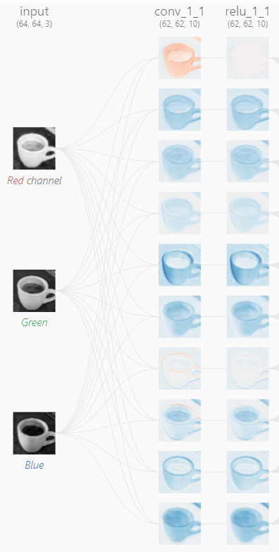

Each of the 10 outputs from the first layer then act as inputs to each of the convolutional units in the second layer. Since we have $10$ **input channels** now, we need $10$ filters for a single unit, all of which will be combined to give a $60×60$ output.

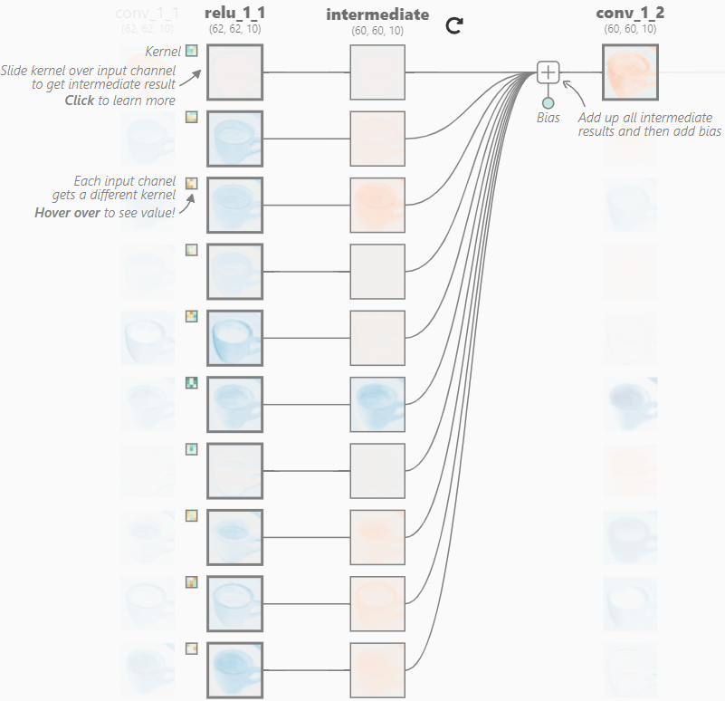

Again, we use $10$ **separate convolutional units**, so the final output is of size $60×60×10$.

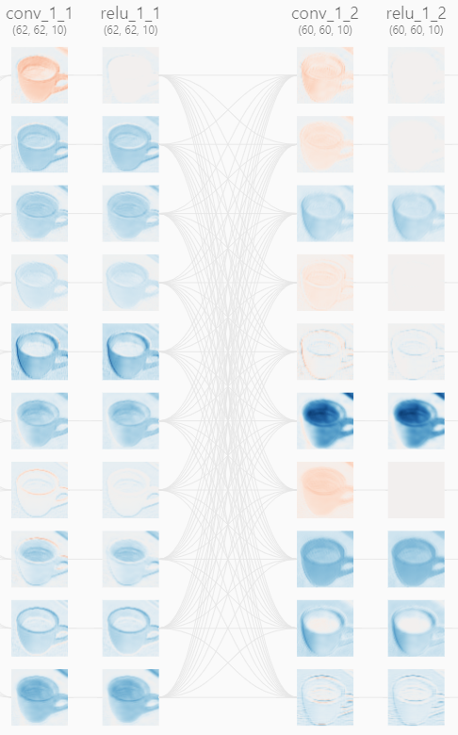

In this manner, we repeatedly apply convolutional layers. In the example here, a total of $4$ layers are being applied. For the time being, ignore the max_pool layers. They are simply a way of reducing the feature size. We will discuss them soon.

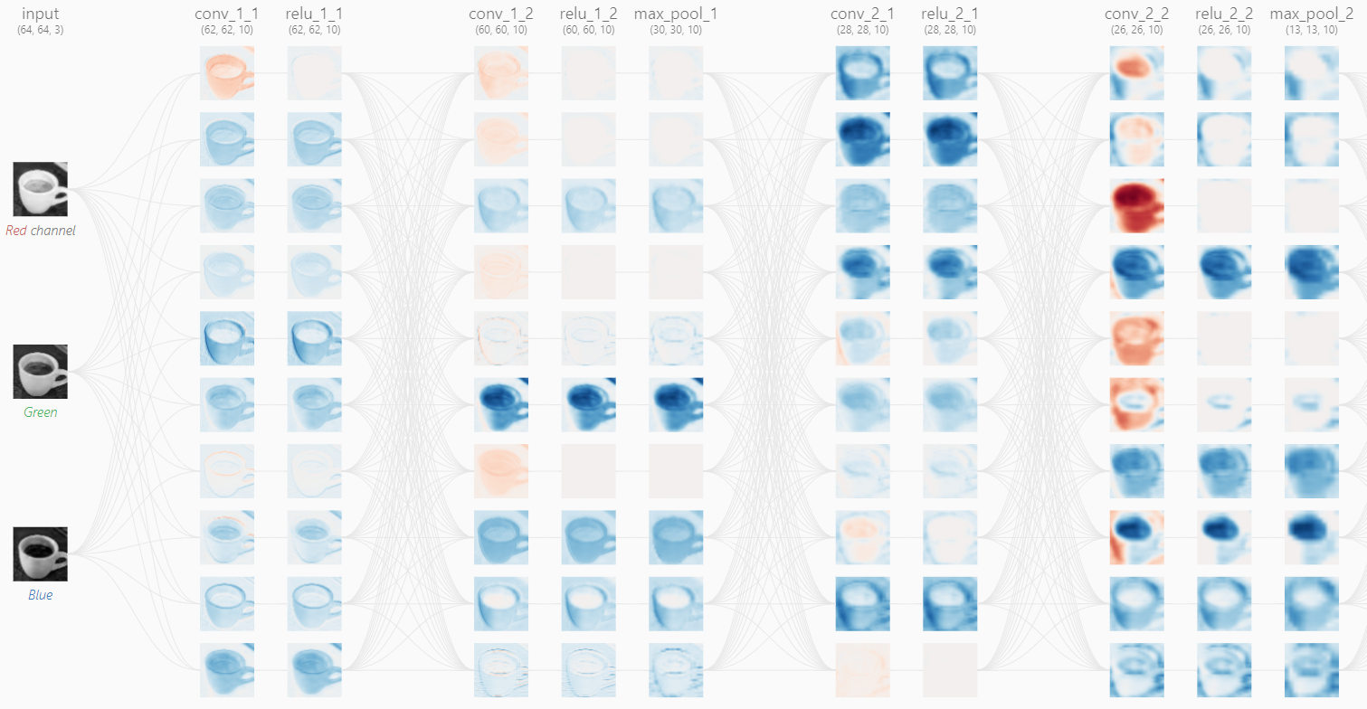

In the final layer, we have 10 different output channels. Each channel corresponds to one of the possible classes. Based on those output channels, we will be able to find the class which has the highest possibility of being correct. We will examine how this works later on.

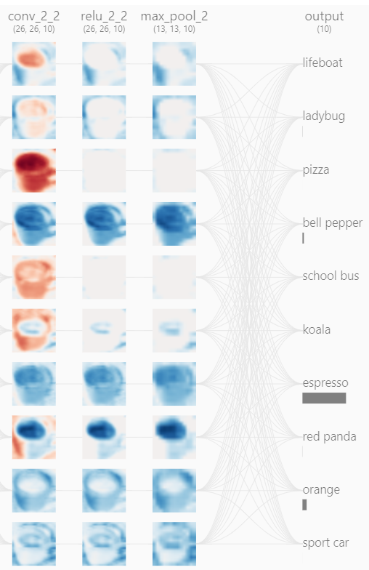

## Pooling Layers

### Max Pooling

We just saw a something called a **max pool**, the objective is to reduce the size of the input. Doing this speeds up computation. We will now examine how this works.

Suppose we have a $4×4$ input and a $2×2$ filter. When performing max pooling, we will apply this filter with a **stride** value of $2$.

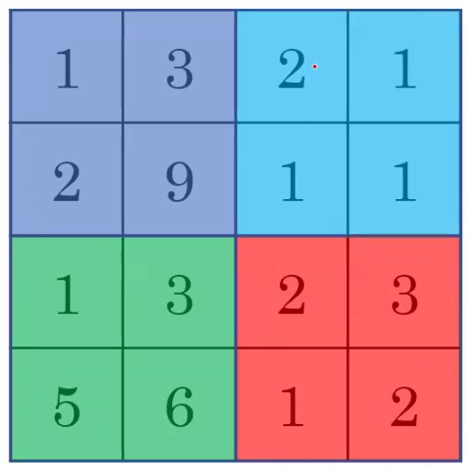

This gives us **four possible positions** with **no overlaps**. At each position, we will take the **maximum value**. Thus, the output will be like this:

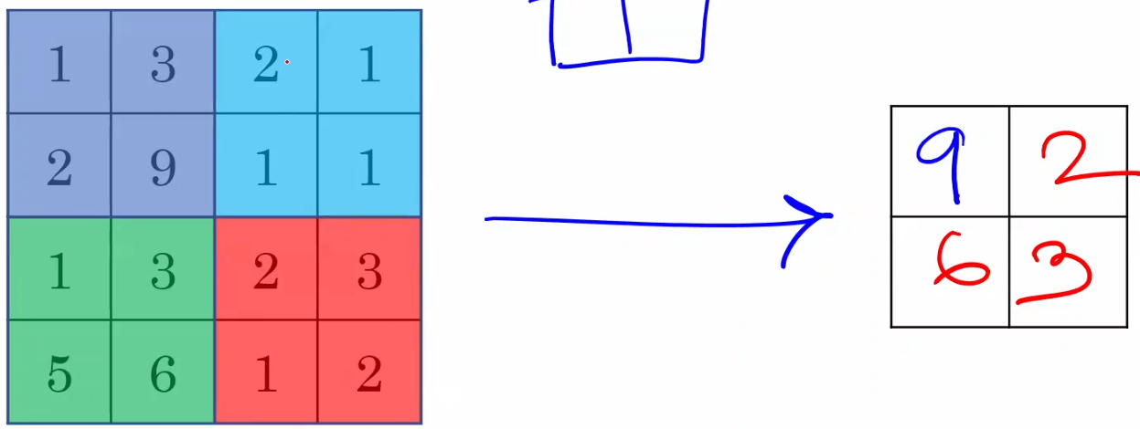

For an $n×n$ input, we use an $\frac{n}{2}×\frac{n}{2}$ filter with a stride value of $\frac{n}{2}$.

Since we are reducing the feature size, this will result in some **loss in accuracy**. To keep this loss to a minimum, we chose the **dominant value** at each position.

The loss in accuracy is theoretically similar to what would happen if we had a stride of $2$ for a normal convolution filter. We would basically be halving the number of features there as well.

Consider that have a $5×5$ convolution filter and a $3×3$ convolution filter. The difference between these two filters will be that the convolution operations for the **larger filter** will be more **computationally expensive**, but will give us a **smaller output**. Thus, we are using more power but also losing more features. Instead, we could use the **smaller filter**, which will use **less power** and also get us a **bigger output**. If we need the output to be smaller as well, we can apply **max pooling**. Thus, a smaller convolutional filter and max pooling combined will get us the same output as the larger convolution filter alone while also using up less power.

### Filter Sizes and Stride Values

We do not necessarily need to have filters and stride values that are half the size of the input. Suppose we have a $5×5$ input and a $3×3$ filter with which we choose to use a stride of $1$. The output would look like this:

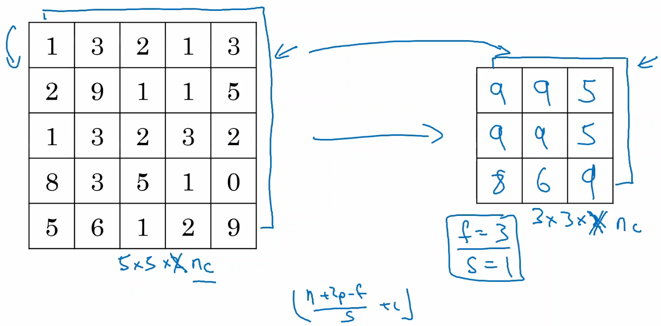

The most common approach however, is to have a filter size of $2×2$ with a stride of $2$.

### Channels

The max pooling operation is applied to channels **individually**. Thus, for an input with $10$ channels, we apply the max pool operation $10$ times to each of the channels and still have $10$ channels in the output. The size of the channels will just be reduced. Unlike convolutional filters, pooling filters only have a **single channel**. They also have **no weights to learn**.

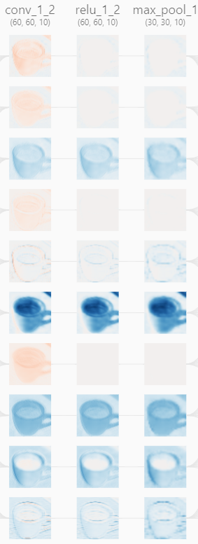

### Other Pooling Methods

Instead of taking the maximum value in each window, we could also take the **average value** or the **minimum value**. The most common approach is to use **maximum pooling**, but which pooling mechanism we should use actually depends on the data.

For images that have a black background with white content, max pooling will give us a better output, since it will be able to most effectively pick out the white content.

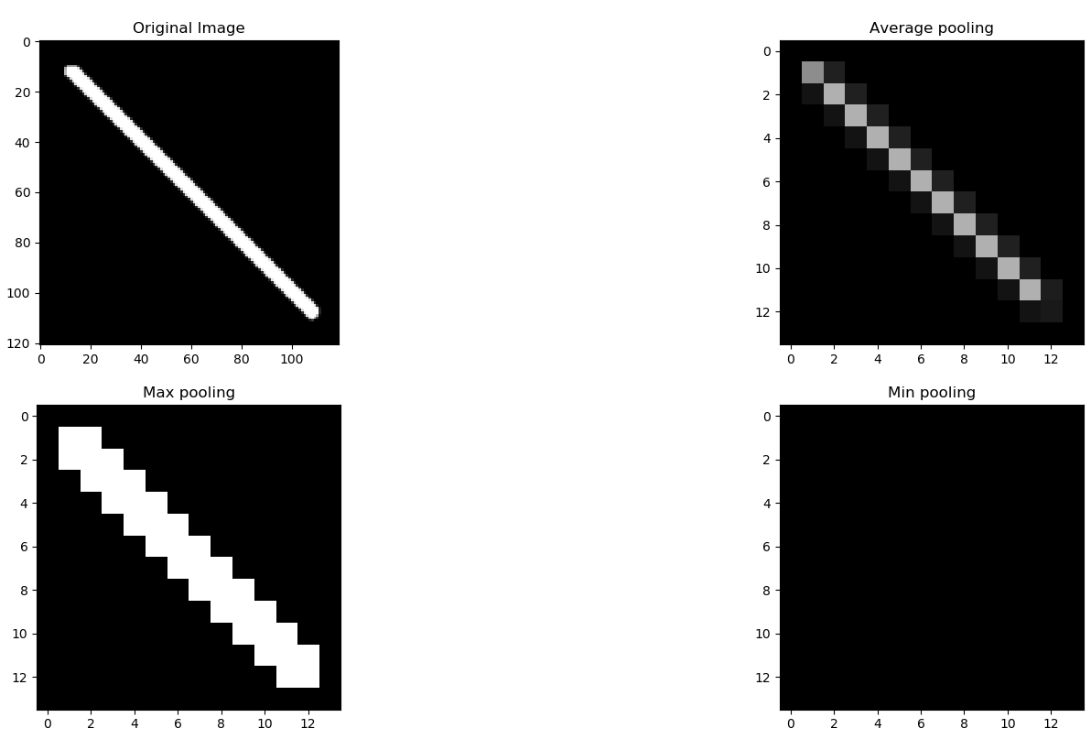

For images that have black content on a white background, max pooling might even discard the content entirely and thus be completely useless, whereas min pooling works wonders.

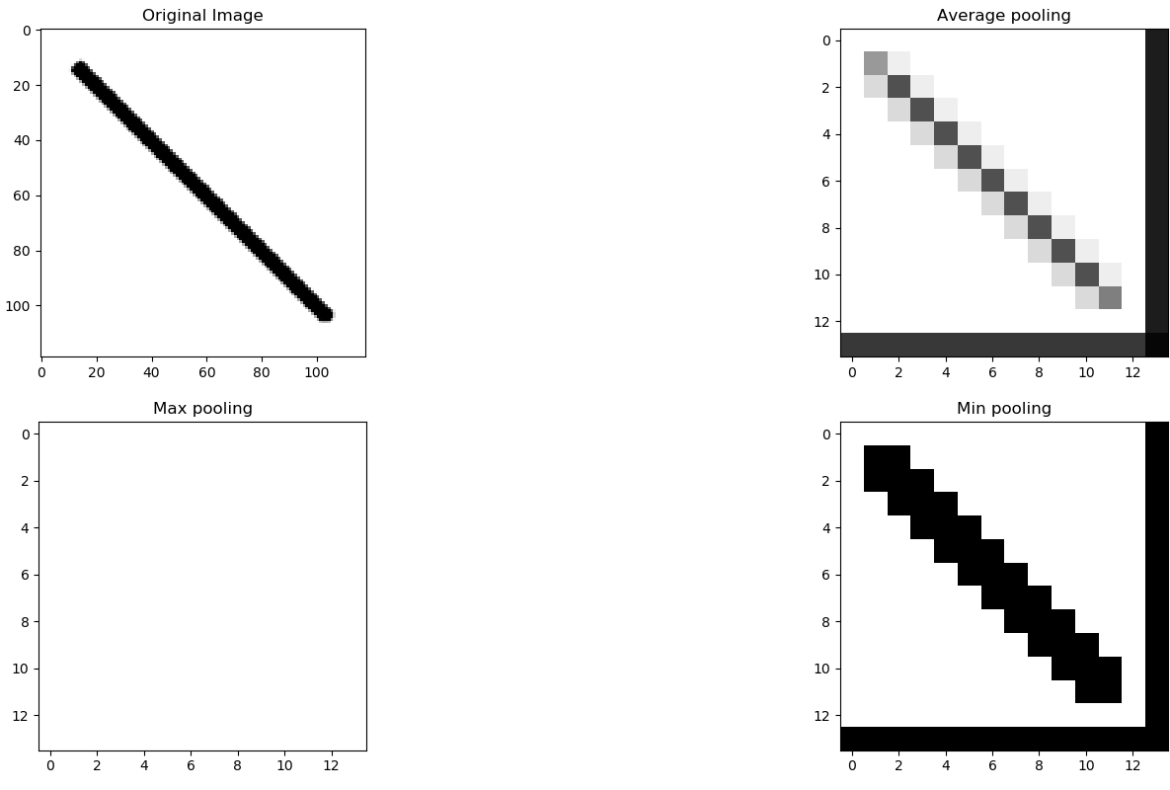

Thus, the type of pooling to use is one of the **hyperparameters**.

**Average pooling** would be a good choice if we want to represent an entire channel with a **single value**. This could be useful if we have reduced the feature size to extremely small sizes, such as $7×7$.

## Forward Propagation

In most convolutional neural networks, as we propagate forwards, the **filter sizes** tend to get bigger and the **outputs** get smaller.

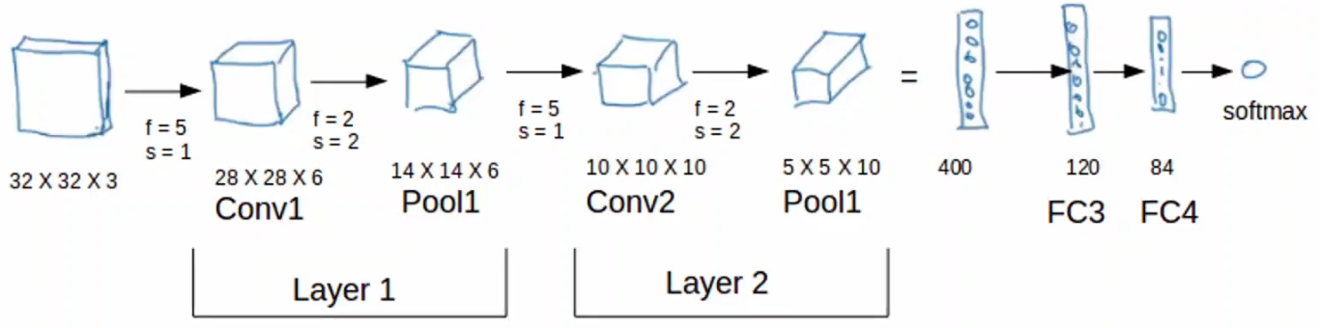

Note: The flattened layer should have 250 units, not 400.

Towards the end, for **classification** purposes, the features are **flattened**. This means the weights of the last block are taken and placed in a vector. Since the last block had $10$ channels, each of size $5×5$, the flattened version has $250$ features.

The flattened features can be passed through more layers called **Fully Connected** (FC) layers. These work like normal neural network layers.

The final output is processed by a **Softmax Layer**.

For the above CNN, we have 6 layers, the input layer, 2 convolutional layers, 2 fully connected layers and a softmax layer. Notice that we do not count the pooling layers and the flattened version of the last block.

Generally, the layers that deal with convolutions are thought of as **feature extraction** layers. The more layers we add to this section, the better the accuracy of our network. As we go forward, generally, the filter size decreases while the number of channels increases. This works because the later layers deal with high-level features, such as the location of a nose, which requires fewer pixels to identify. Thus, we can reduce the size in order to reduce the number of weights we need to learn.

After this, we have the fully connected layers and the softmax layer, which are thought of as the **classification layers**.

## Softmax Layer

Suppose we have a classification problem where the output has three classes. We will use **Fully Connected Layers** to get the number of nodes down to three. However, the values of these nodes can be literally anything, which is not what we want. We want the values to be probabilities, meaning each value needs to be **between $-1$ to $+1$**  and all the values must **sum to $1$** . This is where the softmax layer comes in.

The **softmax function**, also called the **softargmax** or **normalized exponential** function, is a generalization of the logistic function to multiple dimensions. It takes an input vector $z$ which has $K$ real numbers and normalizes it into a probability distribution consisting of $K$ probabilities proportional to the exponentials of the input numbers.

The formula used by the softmax function is:

$$σ{\left(z\right)}_{i}=\frac{e^{z_{i}}}{\sum_{j=1}^{K}{e^{z_{j}}}}$$

Suppose we have a vector $\left[\begin{matrix}1.2 \\ 0.9 \\ 0.4\end{matrix}\right]$. Thus, $\sum_{j=1}^{K}{e^{z_{j}}}=e^{1.2}+e^{0.9}+e^{0.4}$.This gives us an output vector of $\left[\begin{matrix}0.46 \\ 0.34 \\ 0.20\end{matrix}\right]$.

Softmax however, assumes that each example belongs to just **one class**. There may be cases where some examples belong to multiple classes. In those cases, we cannot use softmax and must rely on multiple logistic regression.

## Well-Known Architectures

### LeNet-5

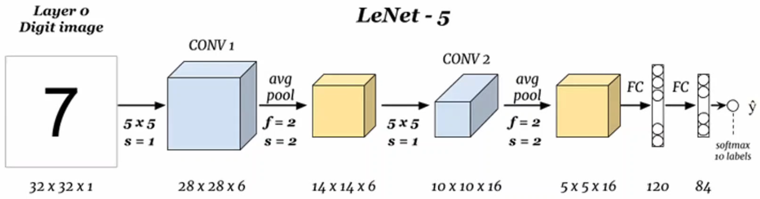

This architecture has approximately $60$ thousand parameters. Notice that the height and width decreases while the number of channels increases as we go forward. This is a pattern that will be seen commonly in other architectures as well.

The layers have a pattern as well. Typically, we will see one (or more) convolution layer(s), followed by a pooling layer. This will be repeated multiple times in the feature extraction portion. Once we get to the classification portion, we will see a few fully connected layers and finally an output layer.

### AlexNet

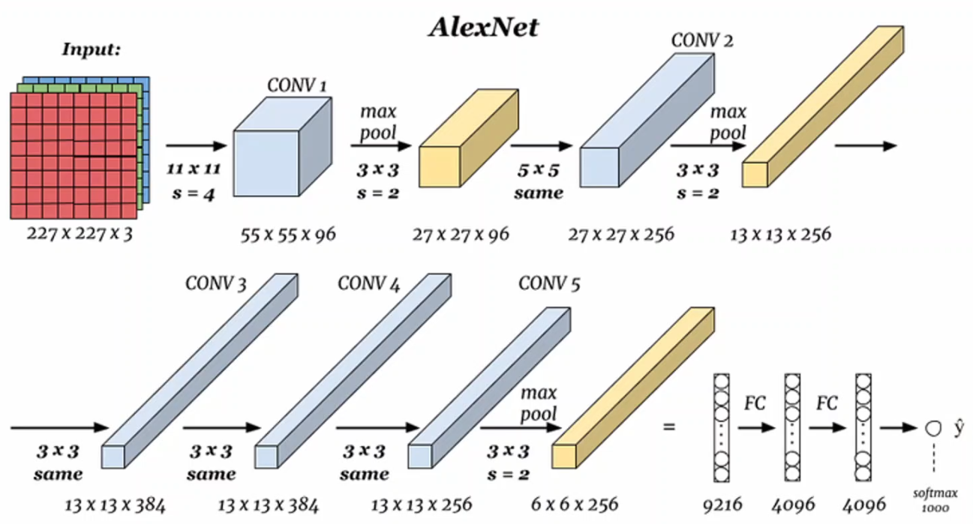

This architecture is similar to the LeNet-5 architecture, except with more convolution and pooling layers. It has approximately $60$ million parameters. Another improvement is that it uses the ReLU activation function, whereas the LeNet-5 architecture used sigmoid and hyperbolic tangent activation functions.

### VGG-16

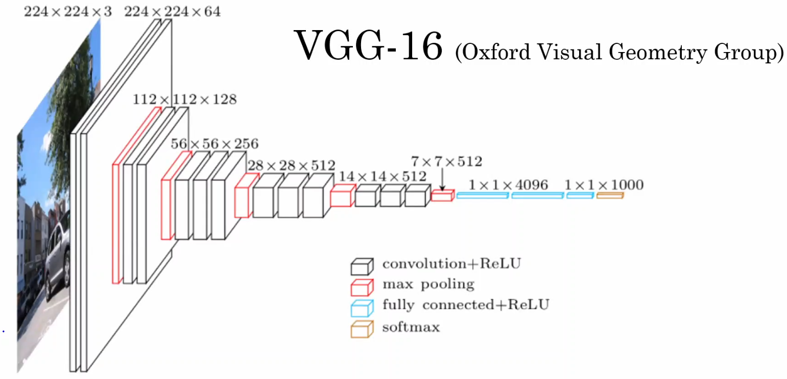

This architecture has approximately 138 million parameters. At every stack of layers, the dimensions are halved and the number of filters is doubled. This makes the choice of hyperparameters much simpler, since all the convolution layers use $3×3$ filters with a stride of $1$ and same padding and all the pooling layers use max pooling with $2×2$ filters and a stride of $2$.

Given several designs such as the ones above, the question arises about how we are to design a network architecture in the first place. This actually takes a lot of experience, so to start with, it might be best to work off of existing architectures that work well.

## Vanishing and Exploding Gradients

One obvious fact about the architectures we just saw is that they are increasingly **deeper**. However, as we keep creating deeper networks, we begin to run into the problems of **vanishing** and **exploding gradients**.

In the backwards propagation step, we must calculate the derivative of the parameter $W$, $dW$. For each layer, the value of $dW$ depends on the values of $dW$ for the layers after it. This is because of the **chain rule**. For very deep networks however, if we have an initial $dW$ value for the last layer that is smaller than $1$, the the $dW$ values for the first few layers will become incredibly small. In fact, they will become so small, that the change in $W$ will be insignificant. This will slow down learning and make it seem like for the same number of epochs, we are getting a higher error with more layers. This is the **vanishing gradient problem**.

On the flip side, we have the **exploding gradient problem**. For the same scenario, if we have a $dW$ value larger than $1$ for the last layer, the $dW$ values for the first few layers will explode. This will cause the value of $W$ to fluctuate wildly, causing divergence.

## Residual Networks

The solution to vanishing and exploding gradient problems was introduced by **residual networks**, commonly called **ResNets**. ResNets skip over some layers, feeding the output from one layer to another layer that is deeper inside the network. When doing this, we just need to ensure that the layers have the same dimensions. If they do not, we need to use padding.

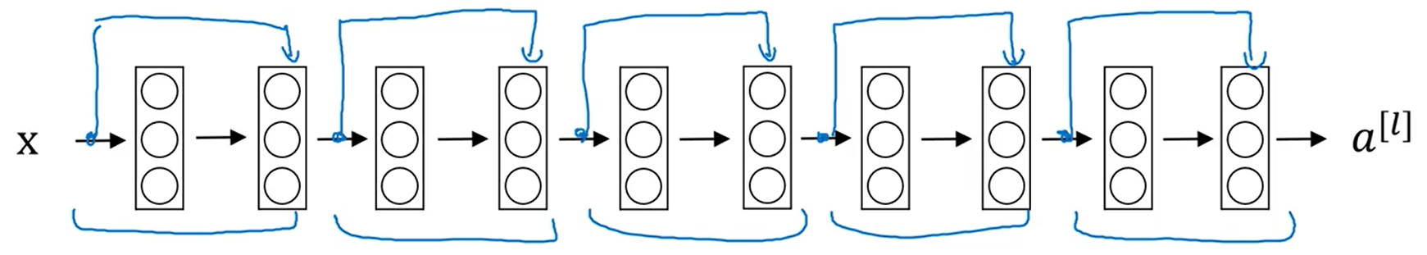

As can be seen in the diagram above, we take the output from one layer, skip one layer, and feed it to the layer after it. The new connection is commonly referred to as a **skip connection**. The point from the start of the skip connection to its end forms a **residual block**.

## 1 x 1 Convolutions

Although it might seem absurd, it is possible to use a $1×1$ convolution. This is done explicitly to reduce the **number of channels**. This in turn reduces the computation cost. Thus, we use pooling layers to reduce the height and width of the image and we use $1×1$ convolutions to reduce the number of channels.

## Inception Networks

When we use a filter, we must make choices for several hyperparameters, such as the size of the filters, the number of channels, etc. If we consider that each filter in our network might be different, this leads to a huge number of hyperparameters, each combination of which will give us a different result in terms of accuracy and performance.

### Inception Modules

The concept behind **inception networks** is to allow the network to figure out which filters to use automatically. Suppose we have an input of $28×28×192$, and we want to choose between a $1×1$ convolution with $64$ filters, a $3×3$ same convolution with $128$ filters, a $5×5$ same convolution with $32$ filters and a max-pool.

Notice that we are using same padding for the convolutions in order to make the output dimensions match the input dimensions. Oddly, we also need to use same padding for the **pooling layer** to make sure the output dimensions match the input dimensions. This is one of the rare cases where this must be done.

However, even with same padding, the **number of channels** for the max pool remains the same. That can be reduced by using a $1×1$ convolution after the pooling. Suppose we use 32 filters for the $1×1$ convolution at this stage.

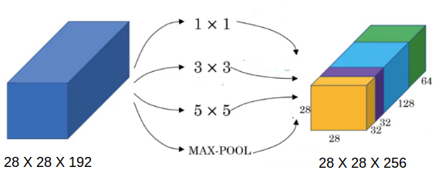

All the outputs from the different filters are then **stacked** on top of each other. For the example we are considering, this gives us a $28×28×256$ output. This is a single **inception module**.

### Computation Costs

One problem with using inception modules however, is the **computation cost**. Consider the $5×5$ filter we used. The total number of multiplications that must be performed for just that filter is $28×28×192×5×5×32≈120 million$.

There is an alternative architecture for this, which applies a $1×1$ convolution first, followed by the $5×5$ filter.

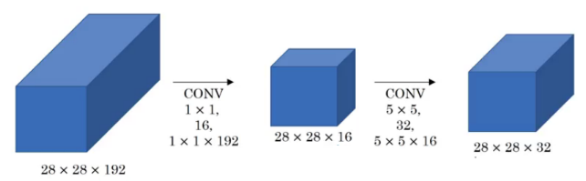

The total computation cost here is $\left(28×28×192×1×1×16\right)+\left(28×28×16×5×5×32\right)≈12 million$. Thus, we can achieve a **10-fold performance increase**. The layer in between is sometimes called the **bottleneck layer**.